1. What are the various elements of the Excel interface? Describe how

they're used.

Ans- The Excel interface consists of several elements that allow users to navigate, view, and edit their workbooks. Here are some of the main elements and their functions:

Ribbon: The Ribbon is located at the top of the Excel interface and contains several tabs, each of which contains related commands. Users can switch between tabs to access different commands and functions.

Quick Access Toolbar: The Quick Access Toolbar is located above the Ribbon and provides quick access to frequently used commands.

Workbook View Buttons: The Workbook View buttons are located in the bottom-right corner of the Excel interface and allow users to switch between Normal, Page Layout, and Page Break Preview views.

Formula Bar: The Formula Bar is located above the worksheet and displays the contents of the active cell, including formulas and values. Users can also edit the contents of cells in the Formula Bar.

Name Box: The Name Box is located next to the Formula Bar and displays the name of the selected cell or range of cells. Users can also use the Name Box to define and select named ranges.

Column and Row Headings: The Column and Row Headings run along the top and left sides of the worksheet and display letters and numbers that represent the columns and rows of the worksheet. Users can use these headings to select and format cells, rows, and columns.

Worksheet Tabs: The Worksheet Tabs are located at the bottom of the Excel interface and allow users to switch between different worksheets within a workbook.

Status Bar: The Status Bar is located at the bottom of the Excel interface and provides information about the current status of Excel, including the current mode and whether certain features are turned on or off.

Overall, these elements provide users with the necessary tools to create and manipulate data in Excel workbooks.

2. Write down the various applications of Excel in the industry.

Ans- Excel is a versatile tool that has a wide range of applications in different industries. Some of the most common applications of Excel include:

Accounting and Finance: Excel is widely used in accounting and finance for financial modeling, forecasting, budgeting, and financial analysis. It allows users to create complex financial models with ease, perform financial calculations, and generate financial reports.

Data Analysis: Excel is an excellent tool for data analysis. It can handle large datasets, perform data cleansing, filtering, sorting, and aggregation. It allows users to perform statistical analysis, regression analysis, and other advanced data analysis techniques.

Project Management: Excel is widely used in project management for creating project schedules, tracking project progress, and managing resources. It allows users to create Gantt charts, critical path analysis, and other project management tools.

Sales and Marketing: Excel is a valuable tool in sales and marketing for tracking sales data, analyzing customer behavior, and creating marketing campaigns. It allows users to create charts, graphs, and pivot tables to visualize data and gain insights.

Human Resources: Excel is used in human resources for tracking employee data, managing employee benefits, and creating employee schedules. It allows users to perform workforce planning, monitor employee performance, and analyze HR data.

Education: Excel is used in education for creating lesson plans, tracking student progress, and analyzing student data. It allows teachers to create grade books, track attendance, and perform statistical analysis of student performance.

Research: Excel is used in research for organizing research data, performing data analysis, and generating research reports. It allows researchers to perform complex statistical analysis, create charts, and graphs, and visualize research data.

These are just a few examples of how Excel is used in different industries. The versatility and flexibility of Excel make it an essential tool for professionals across various fields.

3. On the ribbon, make a new tab. Add some different groups, insert

commands in the groups and name them according to their commands

added. Copy and paste the screenshot of the steps you followed.

Ans-

1. 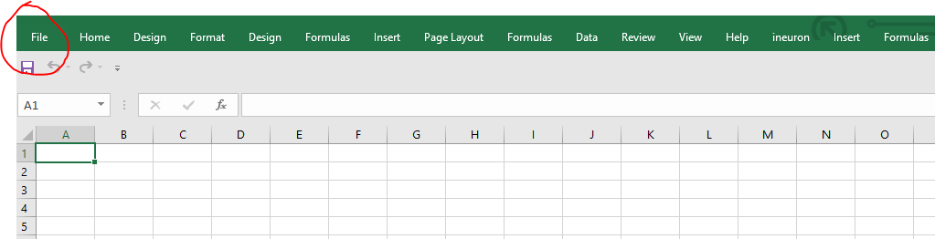
2. 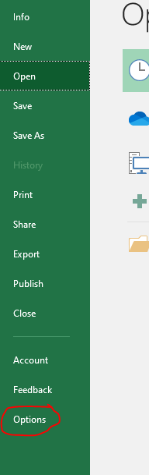
3. 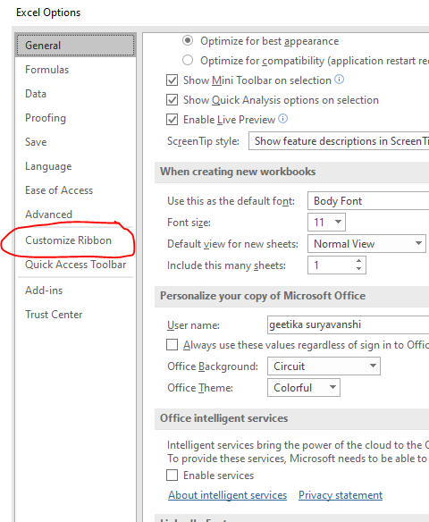
4. 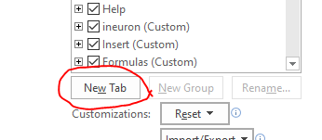
5. 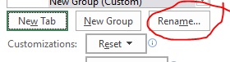
6. 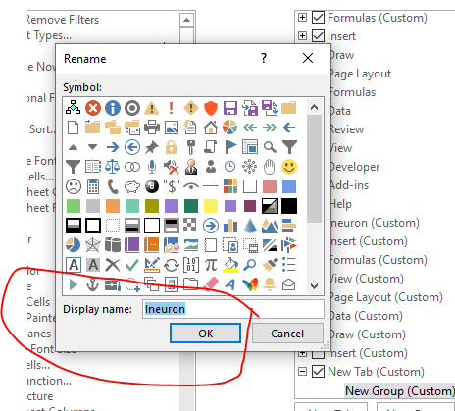
7. 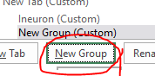
8. 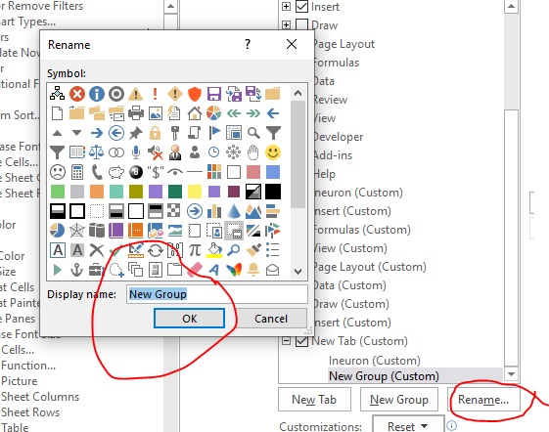
9. 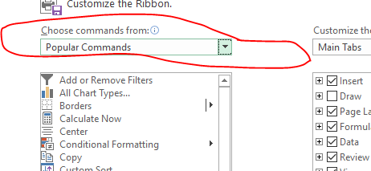
10. 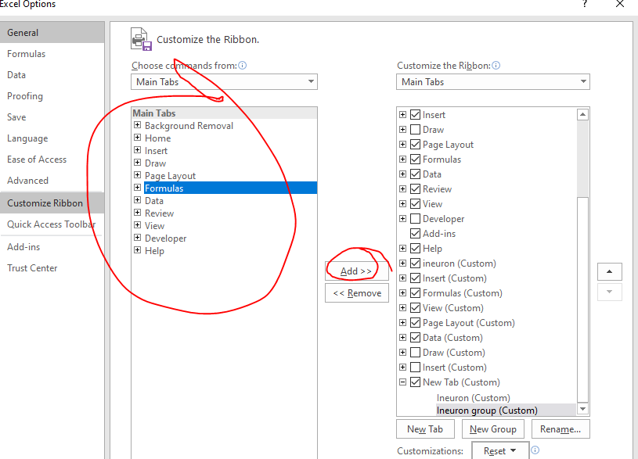

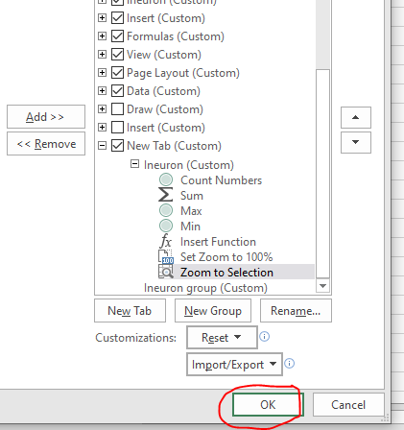

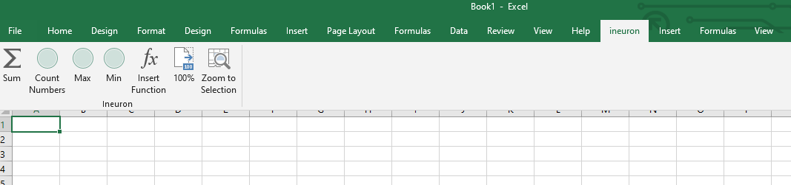

4. Make a list of different shortcut keys that are only connected to

formatting with their functions.

Ans- Here are some common shortcut keys that are only connected to formatting in various programs:

Ctrl + B: Bold text

Ctrl + I: Italicize text

Ctrl + U: Underline text

Ctrl + Shift + >: Increase font size

Ctrl + Shift + <: Decrease font size

Ctrl + Shift + A: Toggle "all caps" formatting

Ctrl + Shift + L: Apply bullet points or numbering

Ctrl + E: Center align text

Ctrl + J: Justify align text

Ctrl + R: Right align text

Ctrl + L: Left align text

Ctrl + Shift + C: Copy formatting from selected text

Ctrl + Shift + V: Paste formatting to selected text

Ctrl + 1: Apply single line spacing

Ctrl + 2: Apply double line spacing

Ctrl + 5: Apply 1.5 line spacing

Ctrl + Shift + S: Apply strikethrough formatting

Ctrl + Shift + H: Apply highlight formatting to selected text.

5. What distinguishes Excel from other analytical tools?

Ans- Here are some factors that distinguish Excel from other analytical tools:

User-Friendly Interface: Excel has a user-friendly interface that makes it easy to navigate and use. Its interface consists of a grid of cells that can be filled with text, numbers, and formulas to perform calculations and analysis.

Spreadsheet Functionality: Excel is primarily a spreadsheet tool, which means it can handle large amounts of data and perform calculations on that data with ease. Users can organize, sort, filter, and analyse data using built-in functions and formulas.

Graphing and Charting Capabilities: Excel has robust graphing and charting capabilities that enable users to create visually appealing charts and graphs to represent data in a variety of formats.

Integration with Other Applications: Excel can be integrated with other applications, such as PowerPoint and Word, making it easy to create reports and presentations using data from Excel spreadsheets.

Customization: Excel is highly customizable, allowing users to create macros, add-ins, and custom functions to automate tasks and streamline workflow.

Widely Used: Excel is widely used across many industries and businesses, making it a popular tool for data analysis and reporting. Its widespread use means that there are many resources available to help users learn and troubleshoot issues.

Overall, Excel's user-friendly interface, spreadsheet functionality, graphing and charting capabilities, integration with other applications, customization options, and widespread use make it a powerful analytical tool that sets it apart from other tools in the market.

6. Create a table and add a custom header and footer to your table.

Ans- Here is an example of a table with a custom header and footer created in Microsoft Excel:

Open Microsoft Excel and create a new workbook.

Click on the "Insert" tab in the top menu and then click on "Table" to insert a new table.

Choose the number of rows and columns we want in our table by hovering over the grid.

Click on the "Table Design" tab that appears when we select the table.

In the "Table Style Options" group, click on "Header Row" and select a style for your table header.

Click on the first row of the table and type in the custom header information.

Click on the last row of the table and type in the custom footer information.

To further customize your header and footer, we can add additional rows or columns as needed.

Once we have finished customizing our table, we can save our workbook or export it in your desired format.

|  |  |  |  |
| --- | --- | --- | --- |
| **Product Name** | **Price** | **Quantity** | **Total** |
| Product 1 | $10 | 5 | $50 |
| Product 2 | $20 | 3 | $60 |
| Product 3 | $15 | 2 | $30 |
|  |  |  | Total: $140 |

To add a custom header and footer in Excel, follow these steps:

Click on the "Insert" tab in the top menu and select "Header & Footer".

This will open the header and footer editing area.

Type in the desired header and footer text in the respective sections.

To add dynamic data, such as the date or time, click on the "Insert" tab within the header or footer editing area and select the desired dynamic data element.

Once you have finished customizing your header and footer, click on the "Close Header and Footer" button to exit the editing area.